

**EMC NetWorker**

**Plugin Configuration Guide**

**Copyright © 2018 Bocada LLC.** All Rights Reserved. Bocada and BackupReport are registered trademarks of Bocada LLC. Vision, Prism, vpConnect and the Bocada logo are trademarks of Bocada LLC. Other product names mentioned herein may be trademarks or registered trademarks of their respective companies.

Protected by U.S patents 6,640,217; 6,708,188; 6,745,210; 7,457,833; 7,469,269; 7,496,614; 8,407,227

The material in this manual is for information only and is subject to change without notice. While efforts have been made to ensure accuracy, Bocada LLC assumes no liability resulting from errors or omissions in this document, or from the use of information contained herein.

Bocada LLC reserves the right to make changes in the product design and documentation without reservation and without notification to its users. 20180828.

Contents

NetWorker Configuration Checklist 4

NetWorker 9.x and above: Preferred Method 4

NetWorker 9.x and above: Alternative method 4

NetWorker 8.x and earlier 4

NetWorker - All versions, all methods 4

Supported Collection Types 5

Data Sources 5

Firewalls and Ports 6

NetWorker 9.x and higher Requirements 6

GST Database User creation and setup on the NetWorker Server 6

Method 1: Using Bocada Scripts to Create GST Database Accounts 7

Method 2: Manual Steps to Create GST Database Account 11

NetWorker Client 15

NetWorker 8.x and older: Enable savegrp.log 16

NetWorker Client 16

NetWorker - All Versions: General Requirements 18

NetWorker – All Versions: NetWorker Client 18

NetWorker - All Versions: Remote Filesystem Access (SMB for Windows or SSH for UNIX) 18

Public/Private Key for log file access (if necessary) 19

NetWorker - All Versions: Communication Ports 20

Bocada Setup 21

Add / Edit Server Properties 21

Server Properties: 22

Advanced Properties (Selected) 24

Selected Additional Advanced Properties (Bocada Support Only) 25

Troubleshooting 26

Technical Support 27

# Extending JobsDB Retention

Used to increase the number of records in query result list for Networker Jobquery command. Used by developers as an additional source for Networker plug-in. The default for the retention of records in the JobsDB is 72 hours.

### Steps to Adjust Retention

1. Launch Networker Management Console (NMC):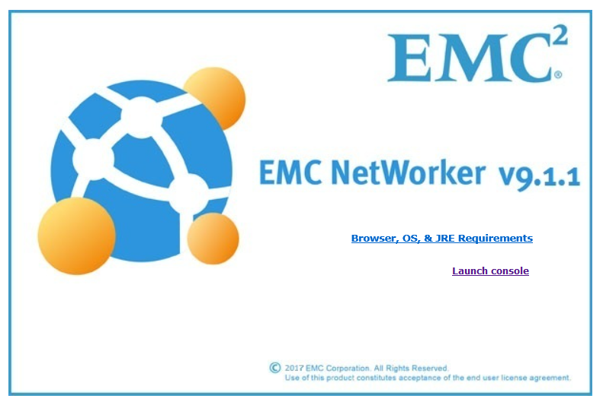
2. Login into NMC
3. Click the **Enterprise** section
4. Select a Networker server from the Enterprise section
5. Select Launch Networker Administration from the right side panel:

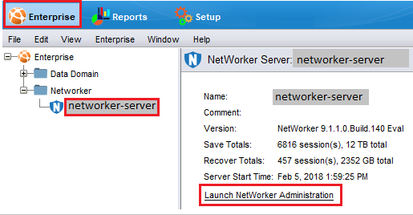

1. Click the **Server** tab

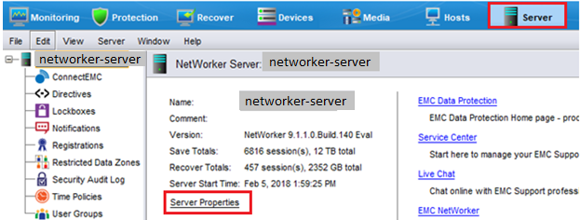

1. Select Server Properties
2. Go to **Configuration** tab
3. Set JobsDB retention in hours to desired level.

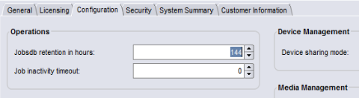

# Technical Support

For technical support or a copy of our standard support agreement, please contact us.

**E-mail:** [support@bocada.com](mailto:support@bocada.com)

**Support Portal:** <http://www.bocada.com/product-support/>

**Phone:** 425-818-4480   
**Toll-free:** 866-BOCADA-1

(866-262-2321)